**DAY – 18-07-24**

**Program for infinite loop**

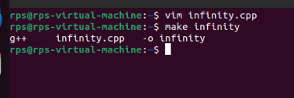

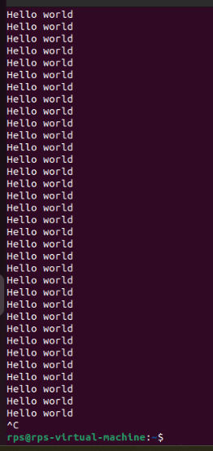

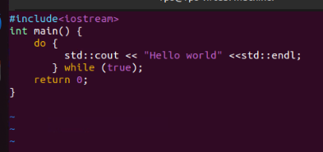

ps-show process status

top-show system usage statistics

kill-stop a program. The program is specified by process ID

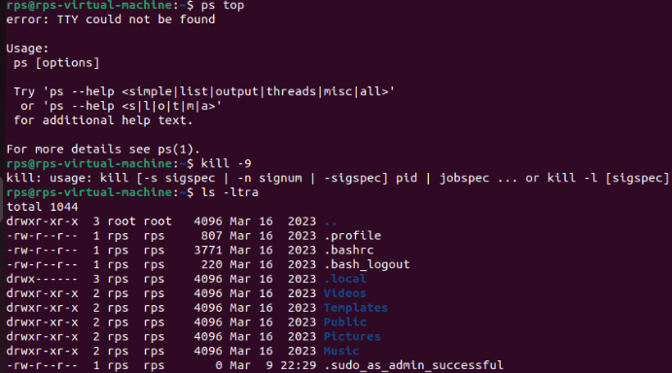

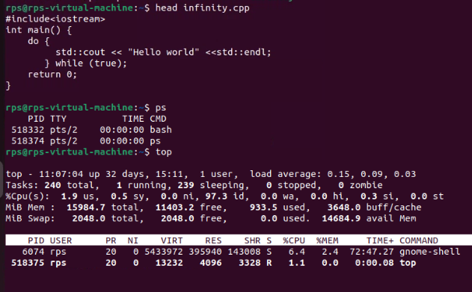

**Program for hello world:**

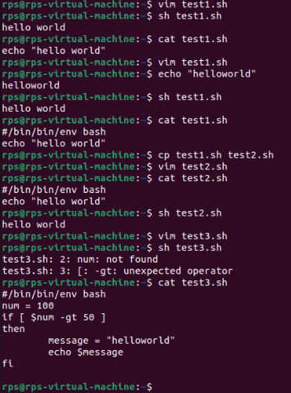

**Program using bash & shell script**

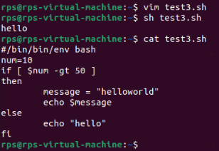

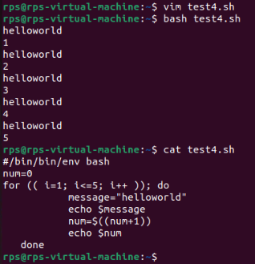

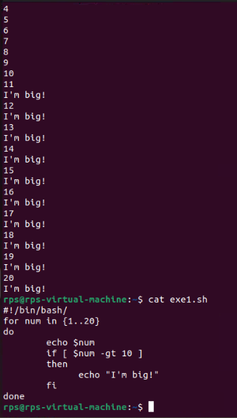

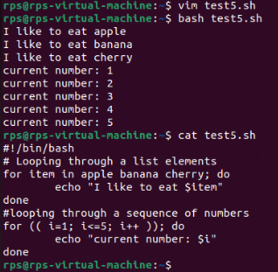

**File Search:**

**1. Write a command to find all files with the extension .txt in the /home directory and its subdirectories**.

**A: find /home -type f -name "*.txt"**

find: The command used to search for files and directories.

• /home: The directory where the search begins.

• -type f: This option tells find to look for files only (not directories).

• -name "*.txt": This option specifies the pattern to match for file names, in this case, files ending with .txt.

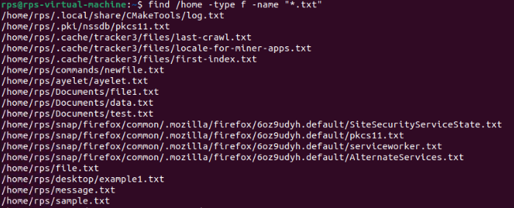

**File Permissions:**

**Write a command to change the permissions of all files in the /var/log directory to 644.**

A: **find /var/log -type f -exec chmod 644 {} \;**

• find: The command used to search for files and directories.

• /var/log: The directory where the search begins.

• -type f: This option tells find to look for files only (not directories).

• -exec: This option allows you to execute a command on each file found by find.

• chmod 644 {}: The command to change the file permissions to 644, where {} is a placeholder for each file found.

• \;: This indicates the end of the -exec command.

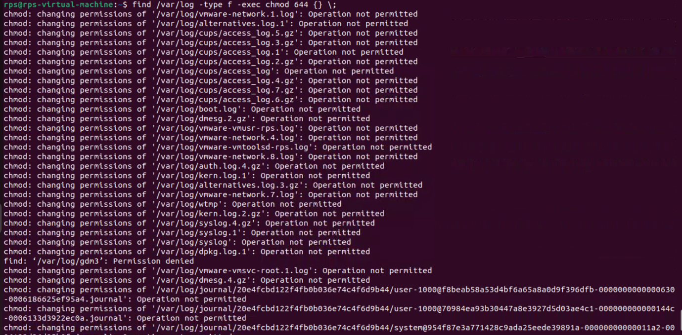

**Disk Usage:**

**Write a command to display the disk usage of all directories in the /home directory in a human-readable format.**

* du (disk usage) reports the amount of disk space used by files and directories.
* -h makes the output human-readable (e.g., in KB, MB).
* --max-depth=1 limits the depth of the directory tree to be reported.
* /home specifies the directory to check.

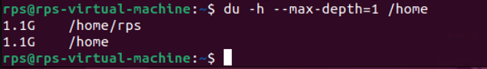

**Process Management:**

**Write a command to list all running processes that contain the name "apache" in their command line.**

ps -ef | grep apache

• ps stands for "process status".

• e stands for "all" and shows all running processes.

• f stands for "full" and shows the full command line.

• grep apache searches for the pattern "apache" in the output of the ps command.



**Text Processing:**

**Write a command to count the number of lines in a file named error.log.**

Network Configuration:

Write a command to display the IP address of all network interfaces on the system.

Package Management:

Write a command to install a package named htop using the package manager.

User Management:

Write a command to add a new user named developer to the system.

File Compression:

Write a command to compress a directory named backup into a .tar.gz file.

System Monitoring:

Write a command to display real-time system resource usage, including CPU, memory, and disk I/O.

Shell Scripts

Backup Script:

Write a shell script to back up a directory named /data to /backup with the current date appended to the backup file name.

Log Rotation:

Write a shell script to rotate log files in the /var/log directory, keeping only the last 7 days of logs.

User Report:

Write a shell script to generate a report of all users currently logged into the system and save it to a file named user_report.txt.

Disk Space Alert:

Write a shell script to check the disk usage of the /home directory and send an email alert if the usage exceeds 80%.

Service Monitor:

Write a shell script to check if the nginx service is running and restart it if it is not.

File Cleanup:

Write a shell script to delete all files older than 30 days in the /tmp directory.

Automated Updates:

Write a shell script to automatically update all installed packages on the system.

Database Backup:

Write a shell script to back up a MySQL database named sales to a file named sales_backup.sql.

System Information:

Write a shell script to display system information, including hostname, OS version, and kernel version.

Cron Job:

Write a shell script to schedule a cron job that runs a specific command every day at midnight.